Chapter 2
IFRS2-4 What are some of the challenges to the IASB in developing a conceptual framework?

IFRS2-5 As discussed in Chapter 1, the International Accounting Standards Board (IASB) develops accounting standards for many international companies. The IASB also has developed a conceptual framework to help guide the setting of accounting standards. While the FASB and IASB have issued converged concepts statements on the objective and qualitative characteristics, other parts of their frameworks differ.

Instructions Briefly discuss the similarities and differences between the FASB and IASB conceptual frameworks as related to elements and their definitions

IFRS2-6 Your aunt recently received the annual report for a company in which she has invested. The report notes that the statements have been prepared in accordance with IFRS. She has also heard that certain terms have special meanings in account-ing relative to everyday use. She would like you to explain the meaning of terms she has come across related to accounting.

Instructions Access the IASB conceptual framework at the IASB website (http://eifrs.iasb.org/ ). (Click on the IFRS tab and then register for free eIFRS access if necessary.) When you have accessed the documents, you can use the search tool in your Internet browser to pre-pare responses to the following items. (Provide paragraph citations.) (a) How is “materiality” defined in the framework?
(b) Briefly discuss how materiality relates to (1) the relevance of financial information, and (2) completeness.
(c) Your aunt observes that under IFRS, the financial statements are prepared on the accrual basis. According to the frame-work, what does “accrual basis” mean

Chapter 3
E3-1 (L02) (Transaction Analysis—Service Company) Beverly Crusher is a licensed CPA. During the first month of opera-tions of her business (a sole proprietorship), the following events and transactions occurred.

April 2 Invested $32,000 cash and equipment valued at $14,000 in the business.
2 Hired an administrative assistant at a salary of $290 per week payable monthly.
3 Purchased supplies on account $700. (Debit an asset account.)
7 Paid office rent of $600 for the month. 11 Completed a tax assignment and billed client $1,100 for services rendered. (Use Service Revenue account.)
12 Received $3,200 advance on a management consulting engagement.
17 Received cash of $2,300 for services completed for Ferengi Co.
21 Paid insurance expense $110.
30 Paid administrative assistant $1,160 for the month.
30 A count of supplies indicated that $120 of supplies had been used.
30 Purchased a new computer for $6,100 with personal funds. (The computer will be used exclusively for business purposes.)

E3-5
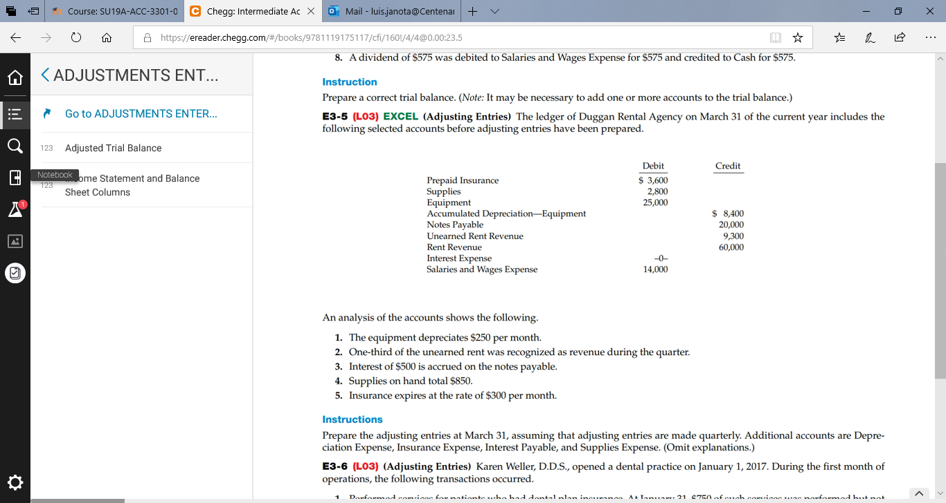

E3-6 (L03) (Adjusting Entries) Karen Weller, D.D.S., opened a dental practice on January 1, 2017. During the first month of operations, the following transactions occurred.
1. Performed services for patients who had dental plan insurance. At January 31, $750 of such services was performed but not yet billed to the insurance companies.
2. Utility expenses incurred but not paid prior to January 31 totaled $520.
3. Purchased dental equipment on January 1 for $80,000, paying $20,000 in cash and signing a $60,000, 3-year note payable. The equipment depreciates $400 per month. Interest is $500 per month. 4. Purchased a one-year malpractice insurance policy on January 1 for $12,000. 5. Purchased $1,600 of dental supplies. On January 31, determined that $500 of supplies were on hand.

Instructions Prepare the adjusting entries on January 31. (Omit explanations.) Account titles are Accumulated Depreciation—Equipment, Depreciation Expense, Service Revenue, Accounts Receivable, Insurance Expense, Interest Expense, Interest Payable, Prepaid Insurance, Supplies, Supplies Expense, Utilities Expenses, and Accounts Payable.

E3-8 (L03) EXCEL (Adjusting Entries) Andy Roddick is the new owner of Ace Computer Services. At the end of August 2017, his first month of ownership, Roddick is trying to prepare monthly financial statements. Below is some information related to unrecorded expenses that the business incurred during August.
1. At August 31, Roddick owed his employees $1,900 in wages that will be paid on September 1.
2. At the end of the month, he had not yet received the month’s utility bill. Based on past experience, he estimated the bill would be approximately $600.
3. On August 1, Roddick borrowed $30,000 from a local bank on a 15-year mortgage. The annual interest rate is 8%. 4. A telephone bill in the amount of $117 covering August charges is unpaid at August 31.

E3-15
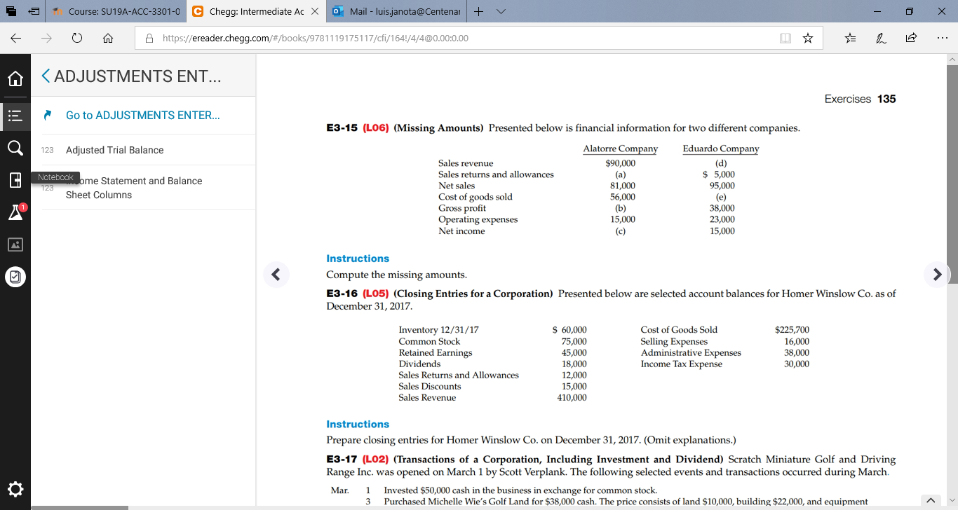

E3-17
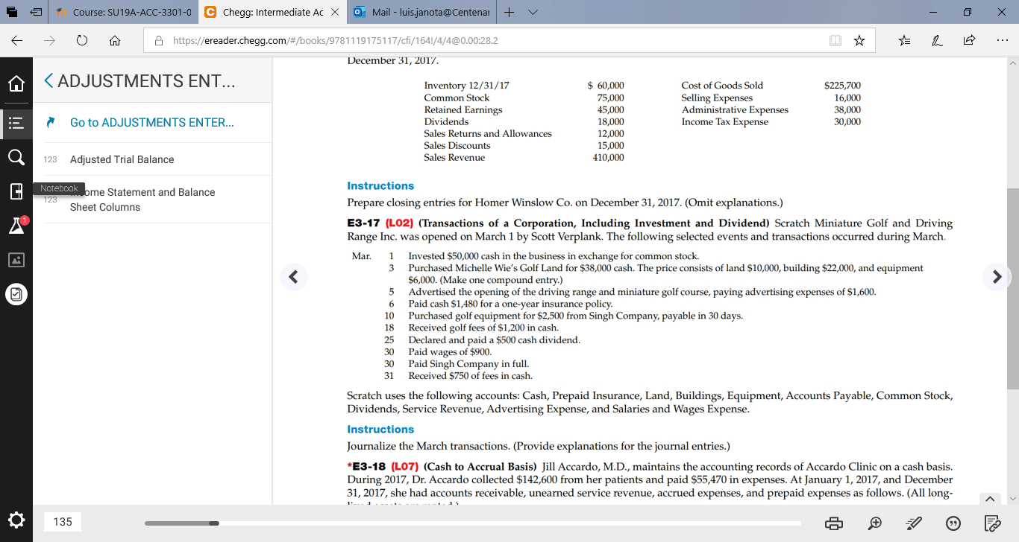

P3-1
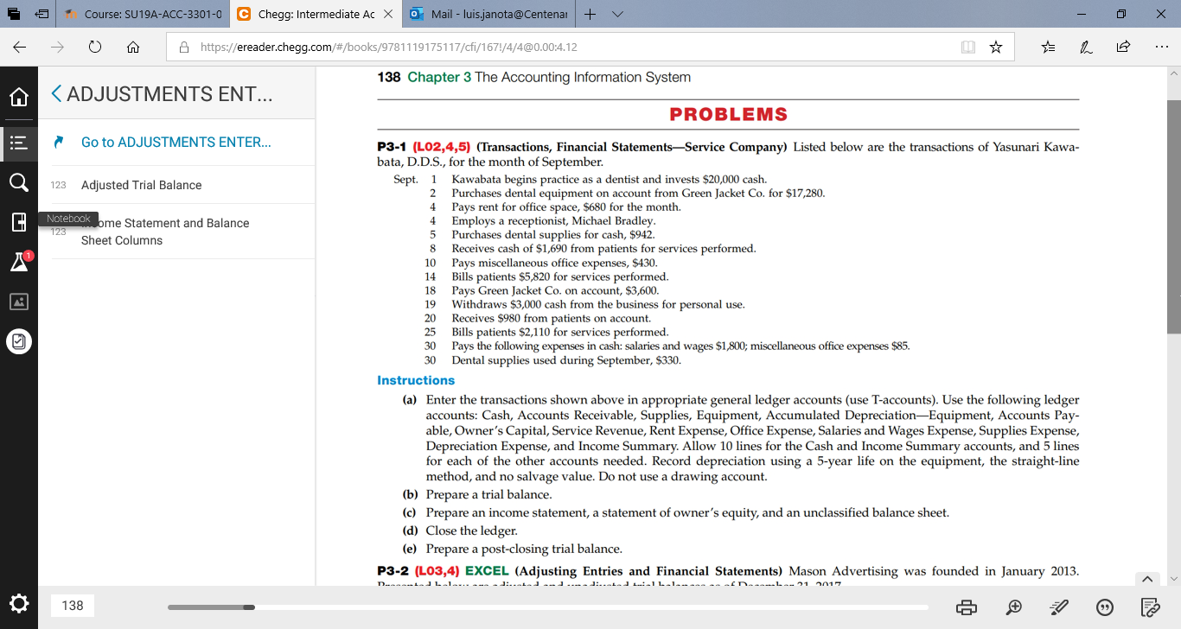

E4-5

Do you receive advertisements through e-mail? Are they directed toward any specific audience or product category? Which ads seem to be most prevalent? Do you pay much attention or just delete them? How much work is it to get off an advertising list?

E4-6

Why would or wouldn’t you try to get off the list? What is it about a company’s Web site that draws you to it, keeps you there on the site longer, and keeps you coming back for more? If you could summarize these answers into a set of criteria for Web sites, what would those criteria be?

E4-8

Compare three different search engines. What tips do they provide to improve a page’s rankings? How much does it cost to advertise a page on their results pages? If you were a company, could you think of any situation where you would pay almost any amount to have the first listing on the first results page?

E4-9

Compare three different search engines. What tips do they provide to improve a page’s rankings? How much does it cost to advertise a page on their results pages? If you were a company, could you think of any situation where you would pay almost any amount to have the first listing on the first results page?

E4-13

Visit www.firstgov.gov. What kind of services do you see that would help you? What services would you use? What areas are missing?

